# DECLARATION

I, **TUYISINGIZE BENJAMIN** I do hereby declare that this internship report document is Entirely the real reflection of my own original work and experience to the best of my knowledge that stemmed from the 10 weeks internship. Any part of this report has not been reported or copied from any report of the university and others.

Signature…………………………

**TUYISINGIZE BENJAMIN**

Date…../…../…..

# CERTIFICATION

This is to certify that Mr **TUYISINGIZE BENJAMIN** a student of University of Rwanda, College of Science and Technology has successfully completed ten weeks of Internship program from January 11st, 2021 to March 22nd, 2021 at UR-GIKONDO CAMPUS(CBE) During the period of his Internship program, we were very satisfied with his performance, he is a quick learner, hard-worker and confident in his work.

We wish his every success in life.

On

Signature

………………………………………………….

**Mr. RUTABOBA Raymond**

Senior Database Administrator at University of Rwanda

# DEDICATION

This work is dedicated to the Mighty Lord who has seen me throughout this internship period in good health and gave me wisdom, discipline and knowledge to get advance in this course. This Internship is also dedicated to my beloved parents with love and advices. Who everyday advices me to work hard and to be the best of my ability and have confidence myself and offered me encouragement, advices, help and all the financial support. Dedication To my friends, Family, all the Staff members of College of Business and Economy and other relatives

Thank you all for the help and support.

# ACKNOWLEDGEMENT

With great humbleness, I would like to extend my sincere gratitude and thanks to my parents for Their sincere support they have given me. I would like to also thank the My family and colleagues for the care and support they gave me all thought my internship. I again thank my fellow trainees like NTWAWUYIRUSHINTEGE Patrick for their good corporation during the training. I would like to thank Mr. RUTABOBA Raymond Senior Database Administrator at University of Rwanda And other staff members of system support department of CBE like Mr. HAGENIMANA Anicet Information Security Specialist at University of Rwanda and also presenting with an opportunity for me to have a practical experience in this CAMPUS I am also grateful to all member for providing several documents, papers, data, figures and services as well as sharing their experience with me and teaching me different techniques to support bidders on the system more effective and efficiently. Thus, the time in CBE very audacious and supportive to my career through which I have gained valuable work experience that will help definitely makes a favorable impression on me as a prospective future employer.

Finally, I also wish to extend my thanks to the University of Rwanda for having introduced the internship program to enable us have a Software experience of the Computer engineering.

# ABSTRACT

This is a third-year industrial training report. The training was carried out in UR GIKONDO CAMPUS as from January 7, 2021 to 15, March 2021, Making the UR ALUMNI system that will assist in giving real and trusted information about University of Rwanda of past years.

UR ALUMNI system also believes in giving advantage to university of Rwanda and other institutions for recruiting employee based on their background. It is for this cause that the UR ALUMNI system is managed by University of Rwanda. This System provides the alumni with an opportunity to experience with meeting opportunities to be one of considerable in future because he/she is in permanent Database. In the near future, This System will implement other all activities for relevant information about University of Rwanda alumni.

UR ALUMNI system is University of Rwanda's only database containing all information about its alumni.

We offer the full access to any alumni in any campus of university of Rwanda and the current Student. And this System aim to keep all alumni’s information for future use.

This report consists five chapters. Chapter one gives a general background information, vision, goal, Core values, policies, coverage map and University of Rwanda Gikondo Campus (CBE). It also entails the objectives of Software Training. Chapter two covers Software concepts I covered. In Software during internship includes that of Database, HTML, PHP, CSS, using of APIs and connecting web pages. Chapter three is about the practical activities carried out on database of UR ALUMNI; making Login page with credentials, connecting database with front end, checking and ensure if all pages are working properly., Chapter four is about the training outcome and conclusion. The last chapter is all about recommendations.

# TABLE OF CONTENTS

Table of Contents

DECLARATION i

CERTIFICATION ii

DEDICATION iii

ACKNOWLEDGEMENT iv

ABSTRACT v

TABLE OF CONTENTS vi

LIST OF FIGURES ix

LIST OF APPENDICES x

CHAPTER 1. INTRODUCTON 1

1.1 Background and necessity of the training 1

1.2 Training objectives 1

1.3 Training prerequisites 2

1.4 Site selection 2

1.5 Training benefits and motivation 3

CHAP 2. LITERATURE REVIEW 5

2.1. Class theories related to site training 5

2.2. Description of the training activities 5

CHAP 3. MATERIALS AND METHODS 7

3.1 Site description 7

This is shown all details about my training during ten weeks. 7

3.1.1 Site localization 7

3.1.2 Brief description of the institution 7

3.2 Brief description of the site tools and equipment 9

3.2.1 Tools: 9

The different hardware and software tools used in this training. 9

3.2.1 Computer 9

3.2.2 Xampp 9

3.3 Exposure of the used methodology 10

3.3.1 Site visit 10

3.3.2 Required training information and data collection 10

3.3.3Site illustrations 10

3.3.4 Site works 12

3.3.6 Books and e-documentation 13

CHAP.4. TRAINING OUTCOMES 14

4.1. Survey map 14

4.2 Description of the training activities 14

4.2.1 Connecting front end and back end using API 19

4.2.2Alumni Form to fulfill with needed information for signup 19

4.2.3 Alumni Form to fulfill with needed information for Future use by Ur Database 20

4.2.4 Page for Welcoming Alumni 22

4.2.5 Resetting Password for Alumni 23

4.2.6 Displaying information of Alumni Sign Upped 24

4.3 Discussions and analysis of the training works 25

4.4 Environmental aspects of the training 25

4.5 Benefit/cost analysis of the training 25

CHAP.5 CONCLUSION AND RECOMMENDATIONS 26

5.1 Conclusion 26

5.2 Recommendations 26

5.2.1 To the Organization 27

5.2.2 To the university 27

5.2.3 Useful remarks 28

5.2.4 Suggestions to the organization 28

5.2.5 Recommendations towards the future trainings 29

REFERENCES 30

# LIST OF FIGURES

xampp viii

Figure 3.1 Computer 9

Figure 3.2 xampp 10

Figure 3.3 UR Gikondo campus site 11

Figure 3.4 Recording Alumni 12

Figure 3.5 MYSQL Workbench 13

Figure 4.1 survey map 14

Figure 4.2.1.1 how to create database connection 19

4.2.3 Alumni Form to fulfill with needed information for Future use by Ur Database 20

Figure 4.8 Page to welcome Alumni 22

Figure 4.8.1 Page for Resetting Password 23

Figure 4.8.2 Page showing Alumni Sign upped 24

LIST OF SYMBOLS AND ABBREVIATIONS

|  |  |
| --- | --- |
| UR | University of Rwanda |
| HTML | Hypertext Markup Language |
| CSS | Cascading Style Sheets |
| CBE | College of Business and Economy |
| PHP | Hypertext Processor |
| API | Application Programming Interface |

# 

# LIST OF APPENDICES

A1. A copy of the the IA requesting letter and acceptance received

A2. A copy of the site introduction letter

A3. A copy of insurance cover

A4. A copy of the site localization filled form

A5. Weekly filled Log Book Schedule

A6. Tutor’s form filled by the internal supervisor

A7. The site training officer filled form i.e. the Training Certificate

A8. The IA Report Assessment form to be filled by the internal examiner

A9. The IA Report Assessment form to be filled by the external examiner

A10. Other details relating the IA report: Tables, Graphs, Photos or sketches

# CHAPTER 1. INTRODUCTON

## 1.1 Background and necessity of the training

An internship was necessary because it enabled me to gain first-hand exposure of working in the real world. It also allowed us to harness the skills, knowledge, and theoretical practice learnt in class.

The great thing about internships is that it taught us about the specific industries and skills required in these industries. This allowed us to understand the careers I want to pursue after graduation from University of Rwanda.

## 1.2 Training objectives

Industrial training involves a planned systematic development of the knowledge, understanding, skills, attitude and behavior pattern required by an individual to perform a given job or task. It is carried out with the aim of achieving the following goals; the following are the objectives of doing Industrial Training:

* To get hands on experience and learn how to work with the different tools used in that field.to achieve interpersonal relationships so as to create a network of professional contacts that to build proactive public relations and corporate responsibility.
* To allow students to develop the spirit of teamwork and Solidarity in order to satisfy a certain cause.
* To enable the student to acquire basic skills and techniques of the Practical work performed in the field by the experts. Through co-creating with those already experienced, we are able to develop our practical capabilities as well.
* To enable the student, relate the theoretical knowledge and practical aspects of networking.
* To make a professional development contribution to the upcoming professionals by providing both hands on skills and theoretical knowledge of the different networking aspects.
* Expose the students to the environment and expectations of performance on the part of engineers in professional networking engineering practice, private/public companies or government entities.

## 1.3 Training prerequisites

## 

I was required to have completed the 3rd year of Computer and software Engineering, have familiarity with networking and software.

## 1.4 Site selection

To decide where I request internship sometimes I first think many things like why this company what they do, what relationship between their services and my studies, what will they help in my career and what will I gain after completing my internship in that company so after thinking all of that questions I decide to go to UR GIKONDO CAMPUS because it satisfy all of that doubts and campus that has all needed for software trainee.

## 1.5 Training benefits and motivation

First of all, UR GIKONDO CAMPUS is Government institution which provide the courses related to software and networking in some sectors which are needed, I was interested on how their environment and network is stetted which motivated to pursue my software and network career in postgrad studies

Finding a job in the software or IT sector can be a real challenge, especially as we currently have no work experience. An academic internship helped us start acquiring the skills and experience that will help us land jobs after graduation.

I did an internship at UR GIKONDO CAMPUS provides work experience to students. Below I’ve listed the main reasons why I did industrial attachment.

**I Gained Work Experience**

At UR GIKONDO CAMPUS, my internship gained hands on work experience that I could not simply get in a classroom setting. As it is not easy to find a company that will hire me straight out of university without any experience, this industrial attachment gave me the experience I need to at least be noticed by any potential employer.

**I Decided on our Career Path**

The world of SOFTWARE AND IT is a huge one, and there are many different careers available to me. On this internship was opening my connection too many people.

**I used our knowledge and Gained Confidence**

There’s a big difference in what we learnt sitting in a classroom and using that knowledge in the real world. Our industrial attachment at UR GIKONDO CAMPUS was a great way to show that I have taken in what I were taught and that I can apply it in a work environment.

# CHAP 2. LITERATURE REVIEW

## 2.1. Class theories related to site training

During my internship in UR GIKONDO CAMPUS, I upgrade my theoretical knowledge, when I have been learnt the course of creating web pages and form validation, and some other aspect of software and networking in the classroom was very difficult to understand. But now I get more than that learned before.

In my internship I was gaining the more thing about Database when I learnt Database it was difficult to know how it works but now, I was knowing more about Database.

## 2.2. Description of the training activities

My training has carried to the site at UR GIKONDO CAMPUS.

I did a Web Pages, Form validation and Database to access Data Entered.

1. **Web Pages**

A hypertext document provided by a website and displayed to a user in a web browser

**2.** **Form validation**

 is a “technical process where a web-form checks if the information provided by a user is correct.

**3.Creating Database**

A structured set of data held in a computer, especially one that is accessible in various ways. Also, database is an organized collection of data stored and accessed electronically from a computer system. Where databases are more complex, they are often developed using formal design and modeling techniques.

**4.Creating API**

An application programming interface is a connection between computers or between computer programs. It is a type of software interface, offering a service to other pieces of software. A document or standard that describes how to build such a connection or interface is called an API specification.

# CHAP 3. MATERIALS AND METHODS

## 3.1 Site description

### This is shown all details about my training during ten weeks.

### 3.1.1 Site localization

UR GIKONDOS CAMPUS is located in Kigali city in Gasabo District, Gikondo Sector

**KK 737 Street, Gikondo, Kigali  
PO BOX 4285 Kigali-Rwanda**.

### 3.1.2 Brief description of the institution

The University of Rwanda is Rwanda's largest higher education institution. University of Rwanda was formed in 2013 through the merger of previously independent public institutions of higher education, the largest of which was the National University of Rwanda.

#### 3.1.2.1 Vision

To be a leading University that develops highly enterprising graduates prepared and dedicated to building a more just and sustainable society locally, nationally and globally, with appropriate innovations that advance quality of life.

#### 3.1.2.2 Mission

To support the development of Rwanda by discovering and advancing knowledge, committed to the highest standards of academic excellence, where students are prepared for lives of service, leadership and solutions.

#### 3.1.2.3 Main Objectives

-Develop interdisciplinary, problem-based academic programs aligned with Rwanda’s development needs.

-Ensure students have the leadership, entrepreneurship and management skills needed to create employment.

-Create applied, evidence-driven, research centers focused on problem solving, aligned with Rwanda’s development needs.

-Develop continuous education programs for upgrading skills and knowledge.

#### 3.1.2.4 Creativity

Ensure students have the leadership, entrepreneurship and management skills needed to create employment

## 3.2 Brief description of the site tools and equipment

### 3.2.1 Tools:

### The different hardware and software tools used in this training.

### 3.2.1 Computer

Computer is electronic tool we have used to run our code in order to get output and it contain all folder of project.



Figure 3.1 Computer

### 

### 3.2.2 Xampp

XAMPP is an abbreviation for cross-platform, Apache, MySQL, PHP and Perl, and it allows you to build WordPress site offline, on a local web server on your computer.



Figure 3.2 xampp

## 3.3 Exposure of the used methodology

### 3.3.1 Site visit

I visited sites of UR GIKONDO CAMPUS which are located in Kigali city in Gasabo District, Gikondo Sector,

KK 737 Street, Gikondo, Kigali  
PO BOX 4285 Kigali-Rwanda.

The goals of visiting site include is observing how that institution Database site and to be explained how the huge database must be managed carefully.

Briefly, visiting site is very important for internship because it helps to be open in mind, learning how to make secure database and making virtual database in case of recovering data lost.

### 3.3.2 Required training information and data collection

### During training I have required to know mainly class related theoretical knowledge about database and making form validation and different techniques used by software and network engineer, I can gain practical skills and social Information on the site. This was achieved through many ways and processes including: Observations, documentations and self-orientation guided

### my trainer.

### 3.3.3Site illustrations

### 

Figure 3.3 UR Gikondo campus site

### 3.3.4 Site works

During site, they are many activities depend on arrangements of institution. My everyday activities included helping UR GIKONDO CAMPUS with different activities. Some of those activities are the following:

**1.Recording alumni**

In my internship many activities I performed in the sites so that I made recording alumni.

This image I was making a the recording alumni into database

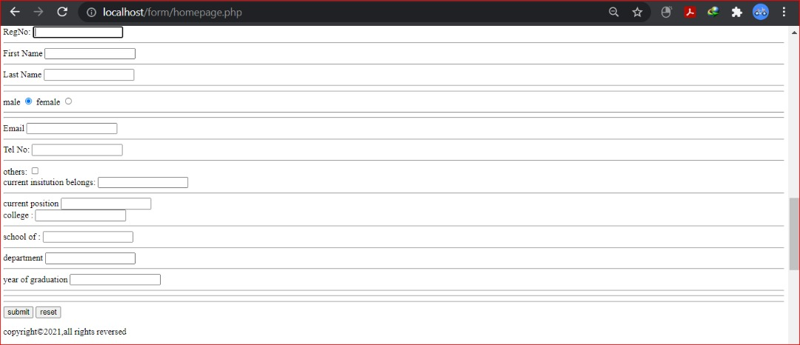

Figure 3.4 Recording Alumni

**2.Checking the Database by MYSQL Workbench**

I have used MySQL Workbench in a unified visual tool for database architects, developers, and DBAs. MySQL Workbench provides data modeling, SQL development, and comprehensive administration tools for server configuration, user administration, backup, and much more.

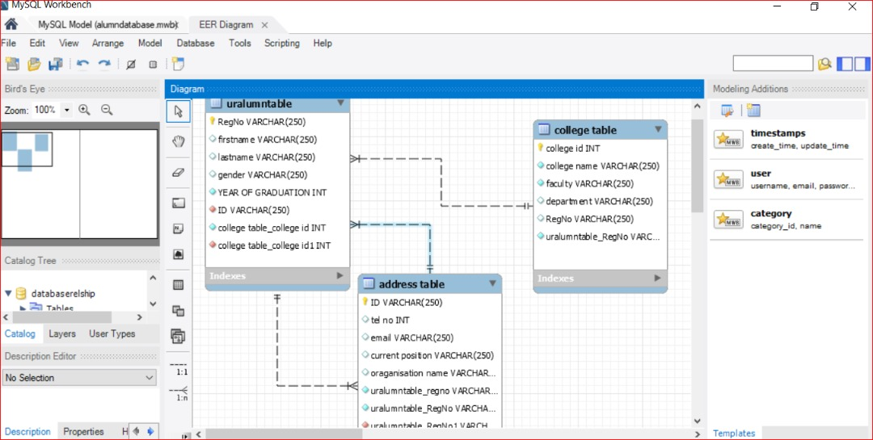

Figure 3.5 MYSQL Workbench

### 3.3.6 Books and e-documentation

Within the past few decades, information technologies have been evolving at a tremendous rate, causing profound changes to our world and our ways of life. In particular, Software and networking has been playing an increasingly crucial role within the telecommunication revolution.

I had read the different books like Design data-intensive applications so that increase the level of knowledge about Database behaviors.

# CHAP.4. TRAINING OUTCOMES

## 4.1. Survey map

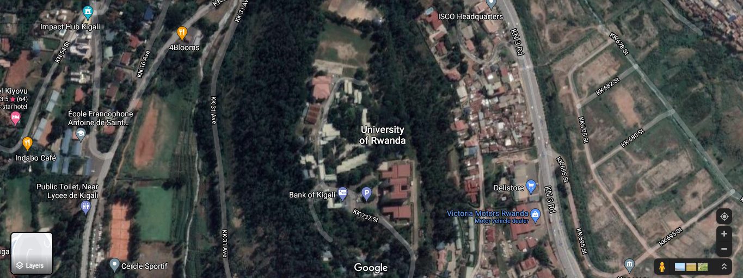

Figure 4.1 survey map

## 4.2 Description of the training activities

My training has carried to the site in at UR GIKONDO CAMPUS as I mentioned database has to be created in order to get more information about alumni.

I did Designing graphical interface, creating database relationship with workbench, implementing our structure in xampp and connecting front end and back end using API.

**1.** **Designing graphical interface**

User interface (UI) design is the process designers use to build interfaces in software or computerized devices, focusing on looks or style. Designers aim to create interfaces which users find easy to use and pleasurable. UI design refers to graphical user interfaces and other forms, the process below was used:

-HTML

-CSS

**2.** **Creating database relationship with workbench**

MySQL Workbench is a unified visual tool for database architects, developers, and DBAs. MySQL Workbench provides data modeling, SQL development, and comprehensive administration tools for server configuration, user administration, backup, and much more.

-MySQL workbench was used

**3. our structure in xampp** **Connecting front end and back end using API**

An application programming interface is a connection between computers or between computer programs. It is a type of software interface, offering a service to other pieces of software.

-Here we had used Xampp, **Steps to Create Xampp**



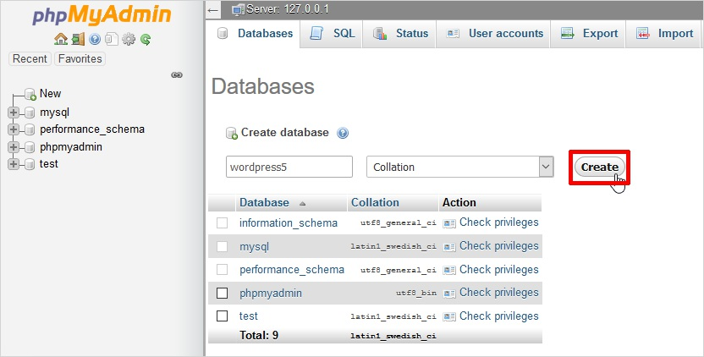

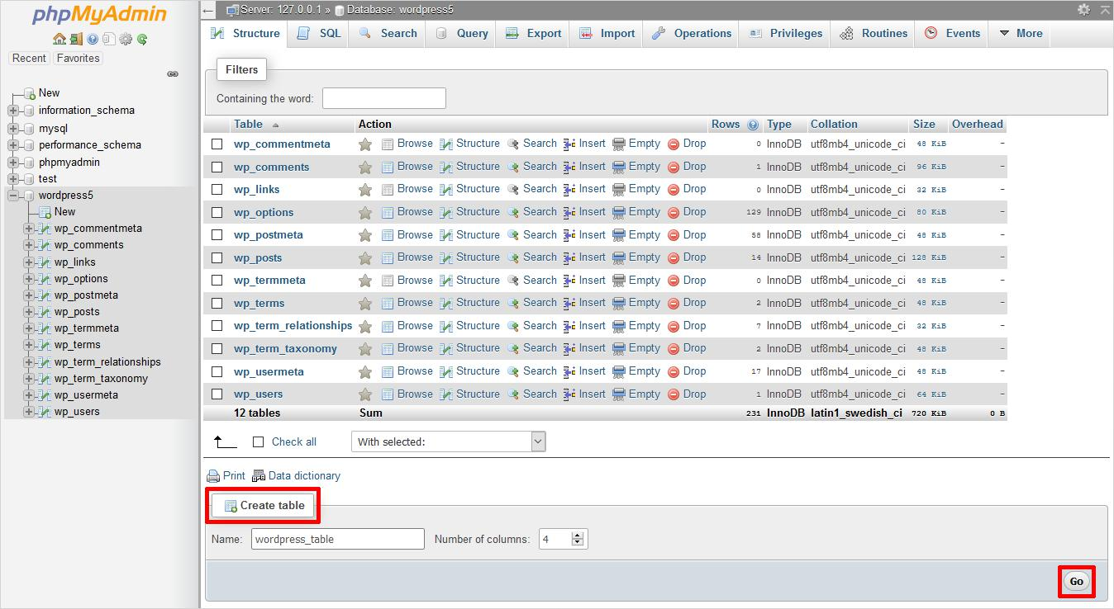

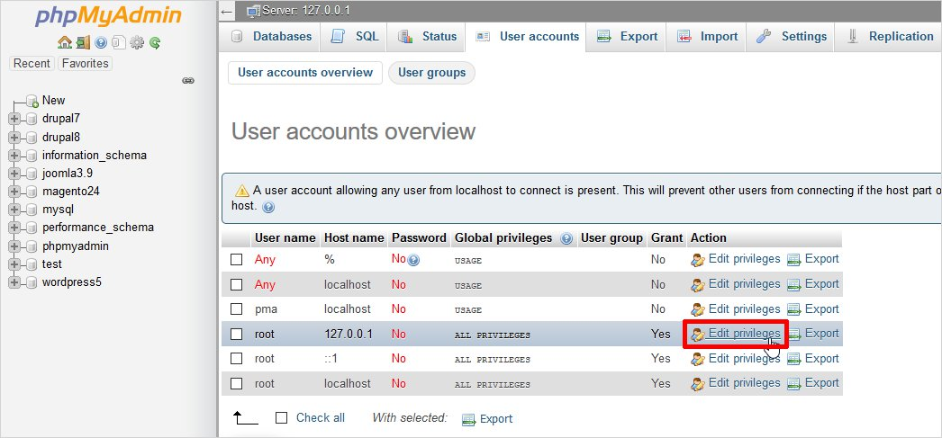

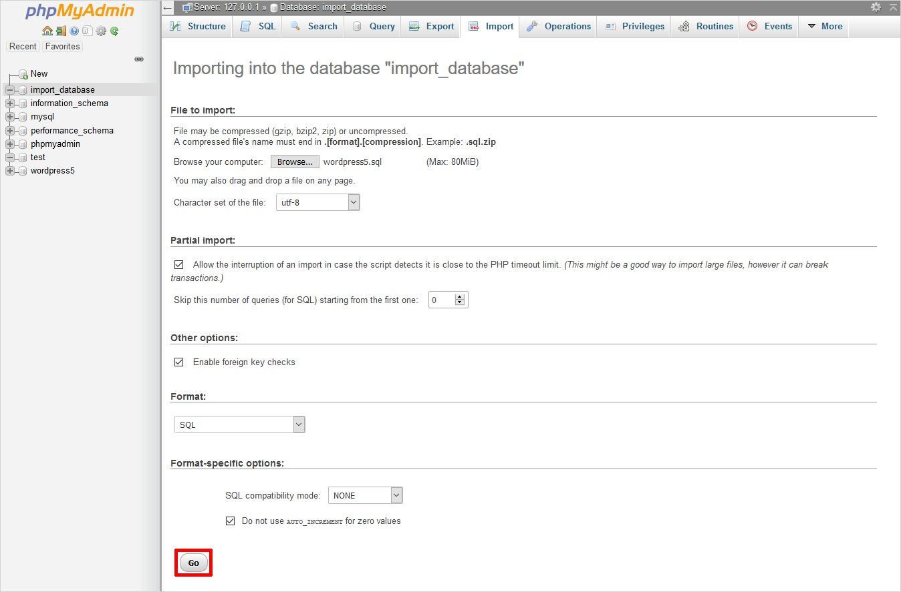

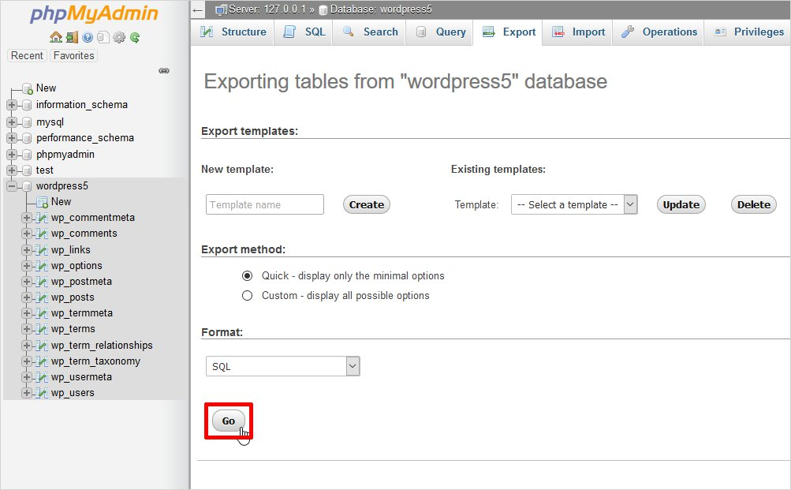

### 4.2.1 Connecting front end and back end using API

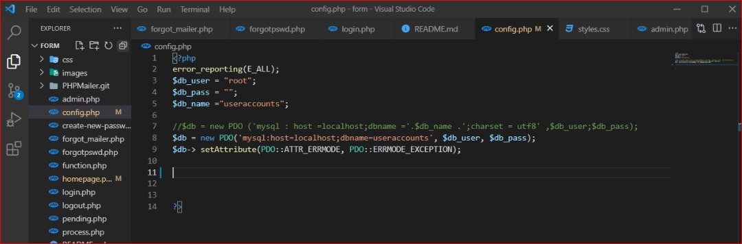

Figure 4.2.1.1 how to create database connection

### 

### 4.2.2Alumni Form to fulfill with needed information for signup

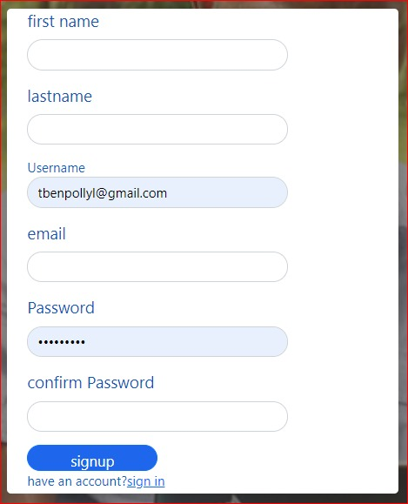

**4.2.3 Alumni Form to fulfill with needed information for Future use by Ur Database**

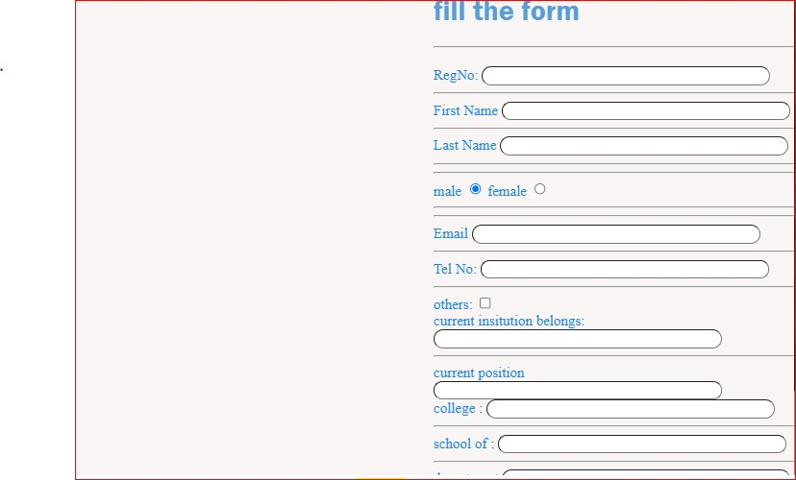

### 4.2.4 Page for Welcoming Alumni



Figure 4.8 Page to welcome Alumni

### 4.2.5 Resetting Password for Alumni

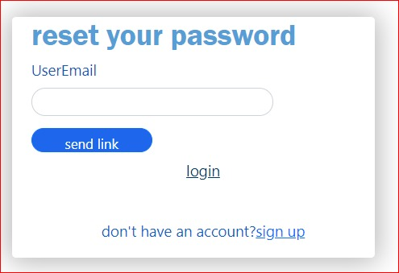

Figure 4.8.1 Page for Resetting Password

### 4.2.6 Displaying information of Alumni Sign Upped

### 

Figure 4.8.2 Page showing Alumni Sign upped

## 4.3 Discussions and analysis of the training works

My training I did many things especially in software and networking field

I made a designing and connecting database to front end in order to make sure user can interact with the system

## 4.4 Environmental aspects of the training

The industrial attachment period was favorable because there were no many interruptions like heavy rainfall and Internet. Most of the time the internet was working slowly. Environment influences site work activities, it is necessary to work in favorable climatic conditions because there are some tools which may be damaged due to bad climatic conditions. During rainy season work continues slowly and this may affect negatively the agreements between owner and institution and also there was that problem of slow network but it didn’t make bad effects. But because the climatic condition was good there were no interruptions or delaying in work.

## 4.5 Benefit/cost analysis of the training

The following are the benefits of the internship:

* It boosts the student confidence once they have the skills about their career
* It helps the students to implement their theoretical skills in practical skills
* Familiarizes students with the environment of companies
* They help the students to increase communication level as well as develop leadership qualities
* The students are provided training from the industry professionals who have assortment of knowledge in working in live-projects
* It gives students the experience of working in professional field with team
* Allow students to pick up (life skills, interpersonal skills, teamwork, etc.) on job
* Internship develops employment records/references that will enhance employment opportunities,

# CHAP.5 CONCLUSION AND RECOMMENDATIONS

## 5.1 Conclusion

After going through the whole period of internship as an intern I've observed so many professional activities and learnt as well. This internship was very fruitful to me because I had to cover many different fields. I also learnt new concepts and new ways of working. During this internship period I acquired practical experience to complement the theoretical content of my study for institution and making many works in recording alumni.

I also learned many things on UR GIKONDO CAMPUS like how to make database and connect it to front end in order to make full exchanging flow of data. To conclude I think this internship was very beneficial to me as I learnt a lot, and it made me discover work's in a real world

## 5.2 Recommendations

I would like to take this opportunity to leave a small note as computer and software engineering student who spent ten weeks in industrial training working with UR GIKONDO CAMPUS:

You can't train someone until you accurately measure the skills, they have relative to the skills they need for success in a given career.

Students going for industrial attachment should be taken through some form of orientation to help them have enough knowledge about what they are about to do.

The attachment is very beneficial to students as it assists them to blend academic work with that of the industry therefore much importance must be given to attachment by students. So, I would recommend to the institutions of high learning to synchronize on the industrial training activity by planning and gradually assessing the performance of the trainee both for the institution side.

### 5.2.1 To the Organization

More opportunities to students to do internship in their organization; the intern would also recommend the Organization To continue giving internship placement to as many students as they can because many students need to know how to database works because many of them will use it their future career some miss this experience which is important requirement of the University due to the fact that they failed to get placements Allowances,

the organization should give allowances to interns most allowances to cater for transport cost most students stay far from the internship places increasing my expenses. Therefore, the intern recommends the Organization action in order to motivate interns and boost their productivity levels in performing their tasks during the field attachment

### 5.2.2 To the university

Constant supervision of students, the intern recommends the university to carry out constant supervision and monitoring of students during the internship training so as to encourage them to perform the duties fully and also accurately This will also put a close link between the academic supervisors and the field supervisors so as to foster appropriate assessment of what the interns are doing in the field. Should continue with internship program, this is because it helps to prepare the students for their careers in future and also enable the students to practice the theoretical knowledge

Obtained during class be exercised practically. It also helps to develop students understanding of work ethics, employment demands, responsibilities and opportunities

### 5.2.3 Useful remarks

"I learned more than I ever expected. I felt in the beginning that I would really have a head start being that I am a senior and have taken all my classes already but I realized that I don't think any amount of classes will ever prepare you for all the world has to offer. don't get me Wrong, I feel that University of Rwanda College of Science and Technology did a wonderful job teaching me but I feel that it is most valuable if combined with first hand work.

I fed during my time interning my most challenging part of my work was to share my tasks and coordinate my work with others. I have always been kind of a perfectionist and to have things done my way so working with others and sharing duties was a slight change I must say. It took me a couple of weeks to really feel comfortable allowing to share my work but eventually I learned it was ok and that heads were better one”

"After doing my internship, I thought that would be enough. but I would strongly encourage students who have the opportunity to do as many internships as possible Even if it's only two days a week at something local, as much experience as possible is great to have once graduation approaches and it's time to apply for jobs."

"Before I intended I wasn't excited about having to do it but after completing my internship I realized this may be probably the best Thing University of Rwanda College of science and technology made me do Being able to utilize all the skills that I was taught at university in real life situation is the best learning experience in the world".

### 5.2.4 Suggestions to the organization

Facilitation; Senior Database Administrator of University of Rwanda should buy more facilities such as more efficient labs and all tools used in programming so as to enable smooth running of the company’s activities and respond to the dynamic competition environment. This would increase the productivity of the institution remarkably.

I also take this moment to request UR GIKONDO CAMPUS to give more opportunities to students by giving as many internship placements as the institution can take.

### 5.2.5 Recommendations towards the future trainings

The student goes to the internship class are owned by the university or the school and are given to the institutions that use or teach us throughout the ten weeks. Therefore, before and after we go to the companies the school must fulfil the following:

* Sending the student to their hosting company because it is hard to find an active company.
* Organizing students those reside in the same place to create a team playing skill and provide group-working environment in order to share ideas.
* Evaluating and supervising student as they are in the site by sending mentors.
* Giving courses that are appropriate for the site work before the internship class is commenced like report writing, quantity survey etc.
* Working with the companies closely to address more knowledge to the student.
* Budget for the internship to student.

# REFERENCES

- <https://blog.templatetoaster.com/xampp-phpmyadmin/>

- <https://www.mysql.com/products/workbench/>

-https://www.interaction-design.org/literature/topics/ui-design